GENERATION OF EVEN NUMBERS

**O**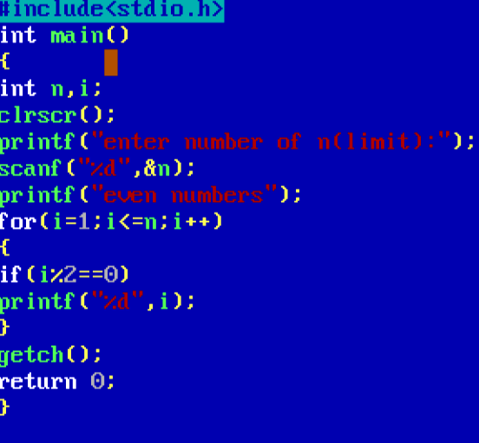

**OUTPUT**

